Chelmsford Junior Netball Club

Newsletter

Welcome to the new season

Taster Day:

We will be holding a Taster Day for Years 3, 4 and 5 on Sunday 30th September, 10.00am to 12.00pm at New Hall School – anyone is free to come along, existing members and new players – please pass the message on

New Coaches:

We would like to extend a very warm welcome to ***Kate Lincoln*** and ***Tracey Bacon*** who will be taking over the running of our Development Squad from September. Kate and Tracey will also be assisted by ***Penny Hart***.

Dates for Diaries:

Year 6/7 Trials: Mon 3rd Sept

League Starts: Sat 8th Sept

Training Starts: Mon 10th Sept

Taster Day: Sun 30th Sept

Fees:

We are increasing our fees this year and these will be as follows:

1st daughter: £75.00 per year

2nd daughter: £65.00 per year

3rd daughter: £55.00 per year

Fees can be paid in full or in two half yearly payments (September and January) by cheque, cash or bank transfer. Please complete the Fees Letter and return to Val Baker, club Treasurer.

Match Fees will still be paid at each Saturday league game and these will remain at £2.00 per game.

Training 2018-2019:

Training returns on Monday 10th September, 6.30pm to 8.00pm at New Hall School on the outside courts

Training in the Sports Hall will be from 6.30pm to 7.30pm and each age group will take a turn, starting with the Development Squad on 10th September

Teams 2018-2019:

You should all have received the results of the trials which were held before we broke up for the summer. If anyone would like to discuss the teams for the new season, please contact Jackie Webb

Extra trials for Year 6/7 will be held on Monday 3rd September, 6.30pm to 8.00pm at New Hall School – if you wish to be selected for one of these teams, please come along.

2018-2019

*Stop press…*

*NEW KIT IS COMING!!*

*We are in the process of rebranding the club and will be updating our kit to dresses. The managers and committee have chosen a new design and an order has been placed for some dresses for everyone to try on so we can then purchase the right sizes. The cost of these dresses will be £38.00 each and hopefully will be available after October half term. Once the sample dresses have arrived, the team managers will measure your daughters and we will place the order. This is the dress we will be having:*

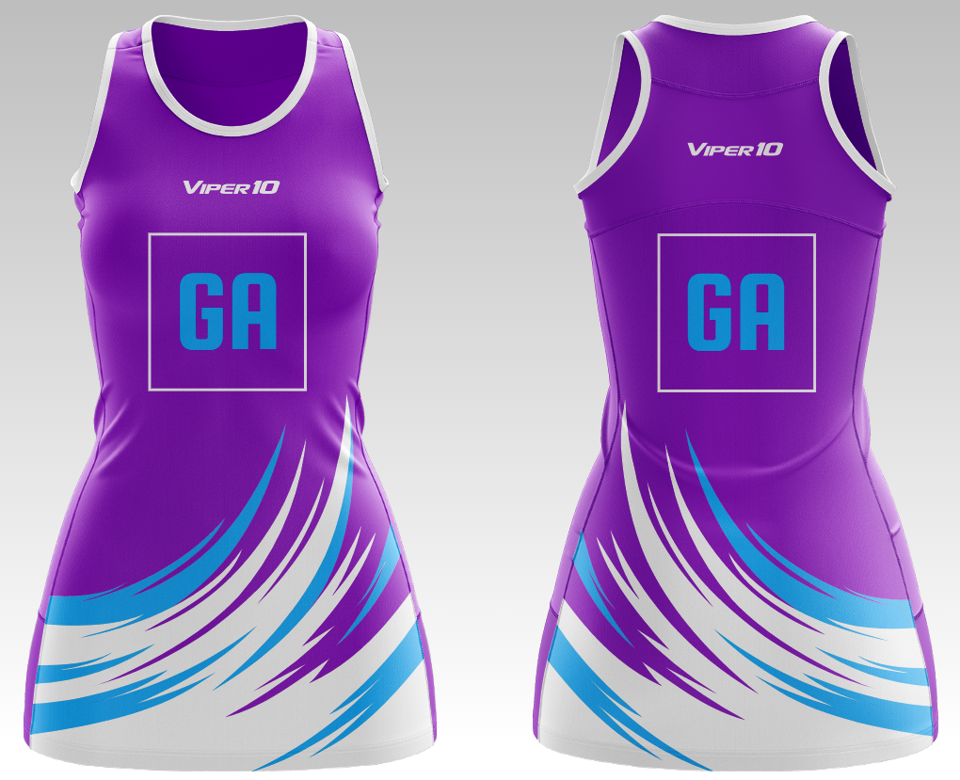

Contacts and useful links:

Club Chair, Jackie Webb: [jax.webb@tiscali.co.uk](mailto:jax.webb@tiscali.co.uk)

Club website: [www.chelmsford-juniors-nc.org.uk](http://www.chelmsford-juniors-nc.org.uk)

Club Facebook: @CHELMSFORDJNC

CDJNL: [www.chelmsfordjuniornetballleague.co.uk](http://www.chelmsfordjuniornetballleague.co.uk)

England Netball: [www.englandnetball.co.uk](http://www.englandnetball.co.uk)

Benecos Mavericks: [www.mavericksnetball.co.uk](http://www.mavericksnetball.co.uk)